TOWN OF CAMPBELL
NEWSLETTER
Sept, Oct, Nov and Dec 2022
www.campbellny.com
~~~~~~~~~~~~~~~~~~~~~~~~~
Campbell Town Board 2022
Jeff Horton – Supervisor
John Tschantre – Deputy
Michael Austin–Board Member
Jamie Drumm – Board Member
Glenn Vogel – Board Member

TOWN BOARD REPORT

Town of Campbell Events:
The Town Board is working to bring more opportunities to the town by hosting Steuben County’s events at the town hall. We started with the Veggie Van on 7/27, 8/17 and 9/7. From 9-11am the Van was in our parking lot selling local vegetables. Steuben County Agencies were here to assist in many areas, including coupons for the Veggie Van. We hope to continue this program next summer. On 8/3 we hosted a seminar on Elder Abuse Awareness with 7 in attendance. Be sure to check our website for future events.
With the major challenges of safety in our community we also looked into a program given by the Steuben County Sheriff’s department. CRASE (Civilian Response to Active Shooter Events). The Sheriff’s department will host a CRASE event and de-escalation class at the Steuben County Public Safety Building in Bath on Sept. 29th 6-9pm. Town of Campbell will be the host of these classes on Saturday, Oct. 15th from 10am – 1pm here and Thursday, Oct. 27th 1-4pm. If interested please call 607-527-8244 Ext 221 to register (please leave your name and phone #). For a more detailed explanation of the class visit alerrt.org site online, it is full of good information.
The 2023 Budget season is here. Tuesday October 11 at our Town Board meeting at 7pm (notice date change due to the holiday) the bookkeeper will present the 2023 preliminary budget. On Oct 12th this budget will be on our website and also available from the Town Clerk M-Th 8am-4pm for your review. A Public Hearing will be held Oct. 24th at 7pm to review the 2023 budget with any questions or concerns.
As always if you have any town concerns please do not hesitate to bring them to myself or any of the Town Board members.
Signing off for 2022 -- Have a safe and Happy Holiday Season!

Jeff Horton, Town Supervisor
(Cell) 607-738-9513
supervisor@campbellny.com

~~~~~~~~~~~~~~~~~~~~~~~~
Highway Superintendent &
Water Operator
Tom Austin
Questions, concerns, Road or Water Emergency
607-769-5123.
~~~~~~~~~~~~~~~~~~~~~~~~~ Town Clerk Report
Michelle Seeley
Mon - Thurs 9am – 4:30pm
townclerk@campbellny.com
607-527-8244 Opt 2 Ext 213

Note from the Town Clerk
I have had several inquiries about the Veteran Flag Project. I will be sending out a letter to anyone who currently has a flag in place, in October of 2022, to see if they want to renew them. I am working with the company that sells the banners to get a quote for the next round of banners and will be placing that information in the January 2023 Newsletter. Once I have that information, and I know how many poles we have available, I will begin accepting applications for new banners. The information will also be available on the website. Thank you for your patience on this project.
If you have not already done so, please sign up for our email list where I post important updates such as all Town, Planning, and Zoning Board meeting agendas, minutes, job postings, legal notices and other happenings in the Town. To sign up go to www.campbellny.com then at the bottom of the home page click the link “Sign up for municipal updates email”.
Thank you for the allowing me to serve our community! Please reach out to my office if there is anything I can do to assist you.
~ Michelle
~~~~~~~~~~~~~~~~~~~~~~~~~
Assessor’s Office
Holley Smalt
TUESDAY ONLY
1st and 3rd In Office
8:30am – 3:30pm
2nd and 4th In office
8:30am – noon
2nd and 4th Field Work
Noon – 3:30pm
assessor@campbellny.com
607-527-8244 Opt 5 Ext 217

Assessor's Corner
Fall is upon us which means renewal exemption time is here for the 2023 Assessment Roll.
Taxable Status Date is March 1st, 2023. Renewal exemptions for Senior Citizen, Disability, and Agricultural Exemptions will be mailed out in November. ALL renewal exemption applications must be submitted by March 1st, 2023. All other new exemptions need to be submitted to me by the Taxable Status Date, March 1st, 2023.
If you have an address change, please contact me so that I can update your file.
If you have recently purchased property you will be receiving a Residential Sale Verification Form in the mail. As part of our continuing effort to maintain accurate property records, we ask that you please complete the Residential Sale Verification Form and return it to my office as soon as possible.
New STaR Applicants need to register with the Department of Taxation and Finance. You may register on-line at www.tax.ny.gov/star or by telephone at 518-457-2036 between the hours of 8:30am - 4:30pm.
~~~~~~~~~~~~~~~~~~~~~~~~~Campbell Town Justices
Patricia Horton
Court Clerk
Kathy Darcangelo
Mon – Thurs. 8am – 4pm
607-527-8244 Option #1
~~~~~~~~~~~~~~~~~~~~~~~~~WATER DISTRICTS
Water Billing
Jacqui Kohman
Mon – Thurs 8am – 4pm
~~~~~~~~~~~~~~~~~~~~~~~~~~~~~
2022 Town Board 7:00 pm
2nd Monday of the month
January 10th
February 14th
March 14th
April 11th
May 9th
June 13th
July 11th
August 8th
September 12th
October 11th
November 14th
December 12th
~~~~~~~~~~~~~~~~~~~~~~~~~
2022 Planning Board 6:00 pm
3rd Wednesday of the month
January 19th
February 16th
March 16th
April 20st
May 18th
June 15th
July 20st
August 17th
September 21th
October 19th
November 16th
No meeting in December
~~~~~~~~~~~~~~~~~~~~~~~~~Campbell Historian
Sandra Austin
Hours by appointment only
607-527-8244 Ext 219
And leave a message

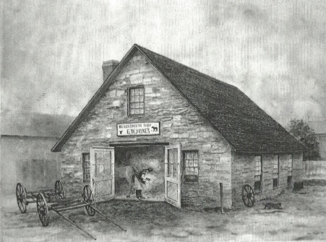
SNIPPETS OF HISTORY
A Little “Stone House” History
As told by Sandy Austin

Located on County Route 333,
near Campbell’s “four corners”, this building was originally constructed around the early 1870’s by George W. Jaynes as a blacksmith shop. Jaynes specialized in making spikes for the Lackawanna Railroad while it was being built in this area. This is the only building in Campbell which is completely constructed of stone, making it an important and is a unique example of historic architecture in the Dutch Colonial style, still in existence.
On the 1873 map of “Campbelltown”, this property is marked “C. W. Noles”. It is believed this was referring to the Charles W. Noles Blacksmith Shop.
On the 1886 map of the Campbell Hamlet, it is listed as “WHEELWRIGHT”. In some old deeds it was referred to as the wagon-shop lot.
In later years it was known as the Frank Hodge Garage and then converted to a residence, and then in about 1980, it was acquired by the Jamisons along with the old small two-story house which was next to it toward the river, and today it is known as the Stone House Café.
~Sandy Austin, Campbell Town Historian

Code Enforcement Office
Tom Hargrave 607-527-8244
Option 4 607-377-4331
Hours: Mon - Thurs 7-8 am & 2-4 pm
codeenforcement@campbellny.com

Please be advised that most home projects require either a building permit or a zoning permit. The easiest way to insure the required permits are obtained is to call our office at 607-527- 8218. By doing this it will assure that your contractor has the proper insurance when on your property.
October is fire safety month. Please change your batteries in your smoke and carbon monoxide detectors if you have the old style. If you have the new style the complete units need to be replaced every (10) years. Also, if you have an emergency fire escape plan it would be beneficial to review at this time especially during the upcoming holidays.
If anyone needs assistance with any of these issues, do not hesitate to call our office so we can help in any way possible.
Cordially,
Tom Hargrave

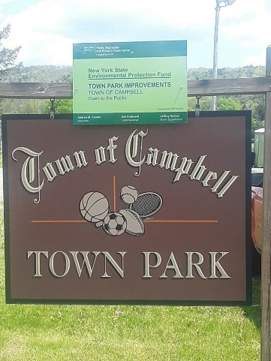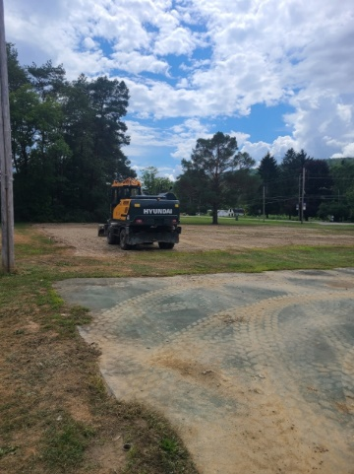

+9Project Administrator
Wendy Oman 607-527-8244 EXT 221
Hours: Mon, Wed, Thurs 10 am – 4pm
Tue 8 am – 5 pm
projects@campbellny.com

Campbell Park Project: The park project is once again underway! The park has been under some major cleanup and construction. The old fencing has been removed, the new tennis court has been laid out along with a new basketball half court.
Water #1 Extension Project: The bids on the construction project have been received and the construction project 1 was awarded at the Sept 1st Special Town Board meeting. A 2nd bidding round on the well house construction only, project 2 bid deadline date is Sept 15th at 1pm. Once the bids are reviewed we hope to award Contract #2. The project is moving forward. Any questions on any of these projects please contact Wendy Oman, Project Administrator 607-527-8244 EXT 221

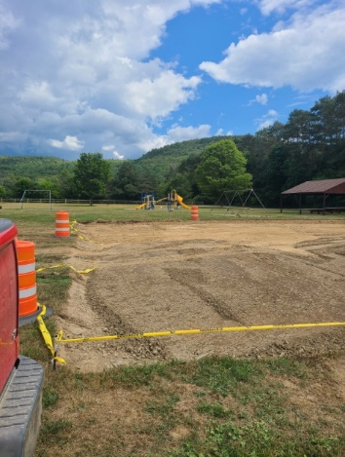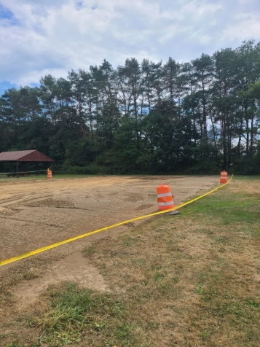

2022 Town Hall Dates at a Glance

September 5-Town Hall Closed
September 12–Town Board 7 pm
September 21–Planning Board 6 pm
October 10-Town Hall Closed
October 11-Town Board 7 pm
October 19-Planning Board 6 pm
November 1-Town Hall Closed
November 10-Town Hall Closed
November 14 – Town Board 7 pm November 16-Planning Board 6 pm
November 23-Town Hall Closed
November 25- Town Hall Closed
December 12-Town Board 7 pm

December 22-Town Hall Closes 12pm
December 26-Town Hall Closed
December 29-Town Hall Closes 12pm

Campbell Town Hall
8529 Main Street
Campbell, NY 14821
607-527-8244 Phone
607-527-8280 Fax

www.campbellny.com

PRST STD

LOCAL POSTAL CUSTOMER
ECRWSS
U.S. POSTAGE
PAID
EDDM

