“CDBG” Grant

Community Development Block Grants (CDBG) are received from the New York State Office of Community Renewal for Septic & Well repairs/replacement necessary for the health and safety of homeowners. Septic repairs or replacements are assessed only after homeowners have had them pumped.

Eligibility Requirements:

- Must be a single family house or mobile home (land must be owned by applicant; land contracts are ineligible)

- Must be the homeowner’s primary residence

- Home must be owned and occupied for at least 1 year, with proof of ownership (deed)

- Taxes must be current or current w/ installment plan (Town, County, School)

- Homeowners insurance must current

- If there is a mortgage, payments must be current

- Income eligibility is based on assets and all gross household income from all people receiving income in the house. The max income is based on HUD income guidelines based on each county

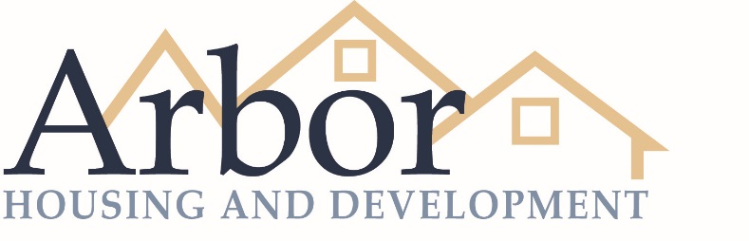
Home Resources - Rehabilitation Program
Georgia Stewart-Tuck, Intake Coordinator 26 Bridge Street Corning, NY 14830 (607) 654-7487 ext.2049
www.ArborDevelopment.org

