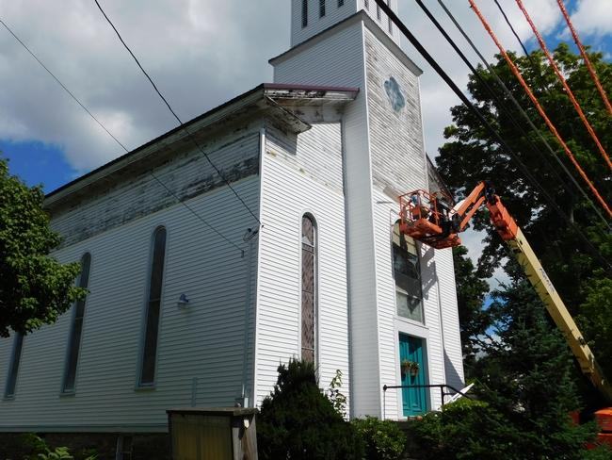
By Stephen Borgna
sborgna@the-leader.com
Posted Aug. 30, 2016 at 5:43 PM
Updated Aug 30, 2016 at 5:44 PM
Corning, N.Y.
CAMPBELL | A historic and symbolic building in Campbell has received a makeover.
A quarter mile drive into the town off of Interstate Route 86, one used to spot a weathered church with beautiful stained-glass windows on the right side of Main Street. Now, that church gleams white with new panel sidings.
The church was built in 1867 by entrepreneur J.D. Hamilton, a wealthy man involved in the town’s tannery business who played an important role in the development of the Campbell community.
Nearly 150 years later, the former Presbyterian church is now the home of “Antiques at the Establishment,” a local antique shop. Roxanne and Mike Mourhess purchased the church for their shop in the late-1990s.
“This stopped being a church in 1997; we purchased it in 1999 and transformed it …,” Roxanne Mourhess said. “It has brought a lot of people in not only for antiquing, but they like to view the Tiffany windows.”
But then the roof started to leak.
“The steeple sprung a leak,” Roxanne Mourhess said. “And it was coming in, and it was starting to deteriorate the ceiling, and the walls. So I had to say, ‘What do I want to do here?’”
“I’m totally in love with this building. I love the preservation of the past … To me, this is kind of a centerpiece of this community; the towering height of it, the Tiffany windows, and the awesomeness of, ‘how did they build this in 1867?’”
She decided to renovate the building. Austin Construction, ACP Construction and Campbell Building Supply are assisting with the project, with a large part of the work being done by Amish builders.
“The Amish have taken on this project, and it is just incredible,” Roxanne Mourhess said.
Maintaining a symbol of the community for now and for the next generation was the most important part of the project, she said.
“I just feel very happy about preserving some part of history … (the building) was probably going to have to be torn down,” Roxanne Mourhess said.
“I’m putting some thousands in it,” she added. “It’s got a roof, and it’s going to have a leak-proof steeple, and I hope the building’s good to go for another 150 years.
“So even if ever a time comes that I don’t have the antique shop here, I’ve preserved the building for maybe its next use, or whomever.”

